* I have complete content layout for iAssistMD from my wix website. This website is informative site only. I would like to have easy backend log-in to add or edit content or pictures in future. Forwarding email for any form is info@iassistmd.com
* I am trying to get all the pictures for this site. (I’ll share a dropbox folder)
* Please make it easy to read and understand.
* Site must be elegant with white background but can use my logo colors, gray and black. (Website should not look cheap from any angles please).
* Menu should have

Home; About Us; Services; Consulting; Blog; Contact Us.

* Consulting (has subtitles)

-EHR/EMR System

-Audit Guard

-Credentialing

* Services (has subtitles)

- Billing

-iDocsNow

-Quick Collect

-Auto Card

1. Home page

Free Practice Analysis and Consultation call  : **888-688-3464** (email symbol) **\*\***  H 

**Welcome to iAssistMD**. We know you're committed to taking excellent care of your patients, but when was the last time you took a close look at your business? We specialize in practice management, revenue cycle optimization, and private practice business support. We have a proprietary analysis tool that can generate a detailed report, outlining solutions for virtually every aspect of your practice. If you're excited by the prospect of a "no headache" billing service that still gives you full control of your patient records, we've got the solution you're looking for.

​

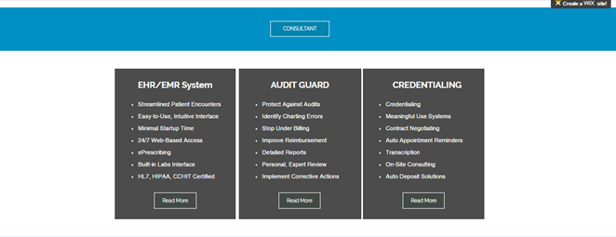

|  |  |  |
| --- | --- | --- |
| EHR/EMR System | AUDIT GUARD | CREDENTIALING |
| * Streamlined Patient Encounters * Easy-to-Use, Intuitive Interface * Minimal Startup Time * 24/7 Web-Based Access * ePrescribing * Built-in Labs Interface * HL7, HIPAA, CCHIT Certified | * Protect Against Audits * Identify Charting Errors * Stop Under Billing * Improve Reimbursement * Detailed Reports * Personal, Expert Review * Implement Corrective Actions | * Credentialing * Meaningful Use Systems * Contract Negotiating * Auto Appointment Reminders * Transcription * On-Site Consulting * Auto Deposit Solutions |

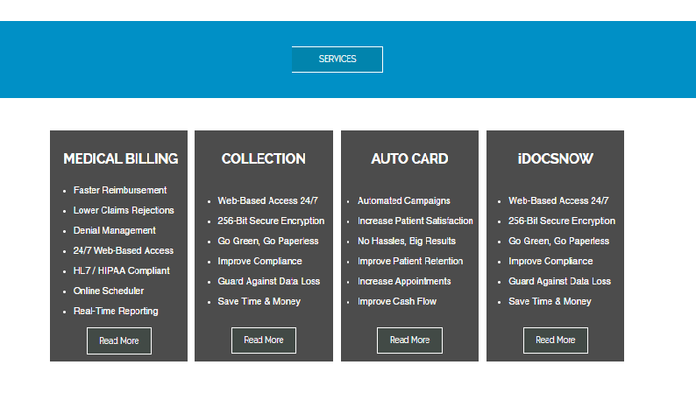

|  |  |  |  |
| --- | --- | --- | --- |
| MEDICAL BILLING | Quick Collect | AUTO CARD | iDocsNOW |
| * Faster Reimbursement * Lower Claims Rejections * Denial Management * 24/7 Web-Based Access * HL7 / HIPAA Compliant * Online Scheduler * Real-Time Reporting | * Triple the Average Recovery Rate * Fully Automated Process * Alternative to Collection Agency * Low Cost Solution * Detailed Reporting * Increased Client Retention * Proven Results | * Automated Campaigns * Increase Patient Satisfaction * No Hassles, Big Results * Improve Patient Retention * Increase Appointments * Improve Cash Flow | * Web-Based Access 24/7 * 256-Bit Secure Encryption * Go Green, Go Paperless * Improve Compliance * Guard Against Data Loss * Save Time & Money |

**When Was the Last Time Your Practice Had a Checkup?**



Keeping up with the ever-changing demands of patient care can be a daunting task. When is there time to find solutions for the daily needs of your practice?

We have a network of over 1,500 offices that specialize in just about every aspect of practice management. Our goal is to provide answers to your practice needs so that you can stay focused on providing great care to your patients.

So the next time you need to research a solution for your office, give us a call. Let us take the stress out of maintaining your office needs, and let us fully optimize every process that your practice requires to run smoothly.

**Isn't it time you took a few minutes to focus on your needs?**

**Let us help you keep your business as healthy as you keep your patients.**

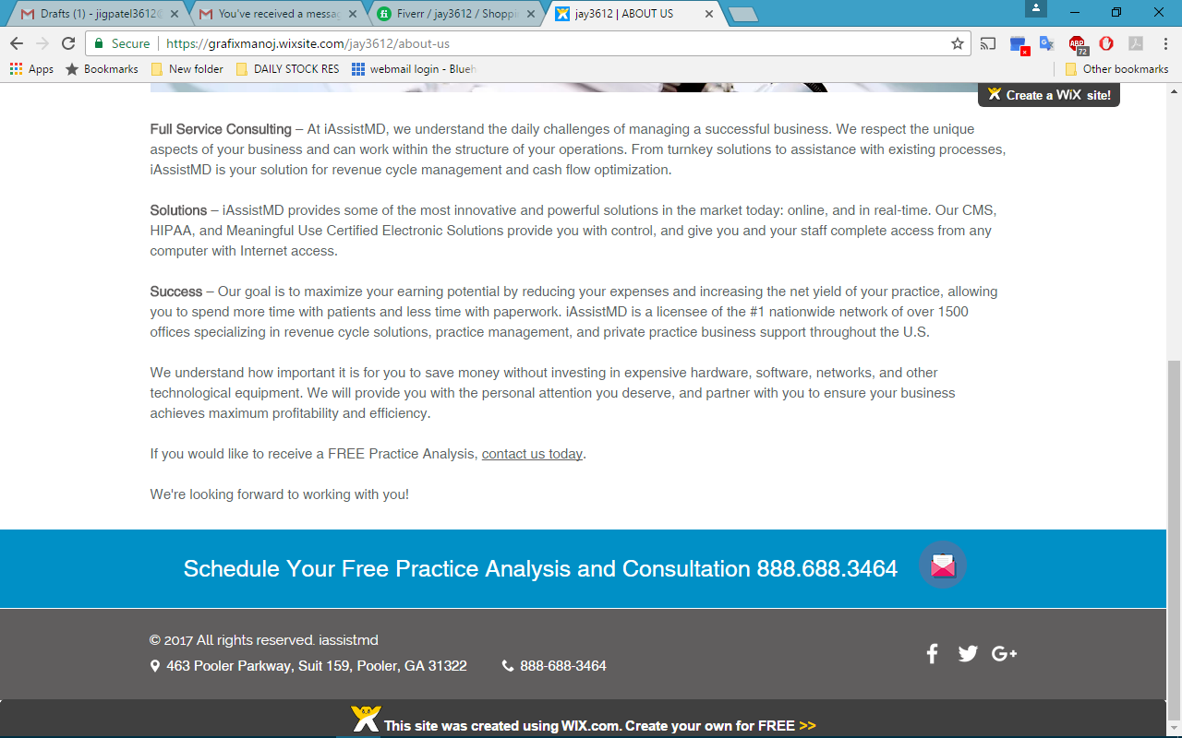

1. About us

About us

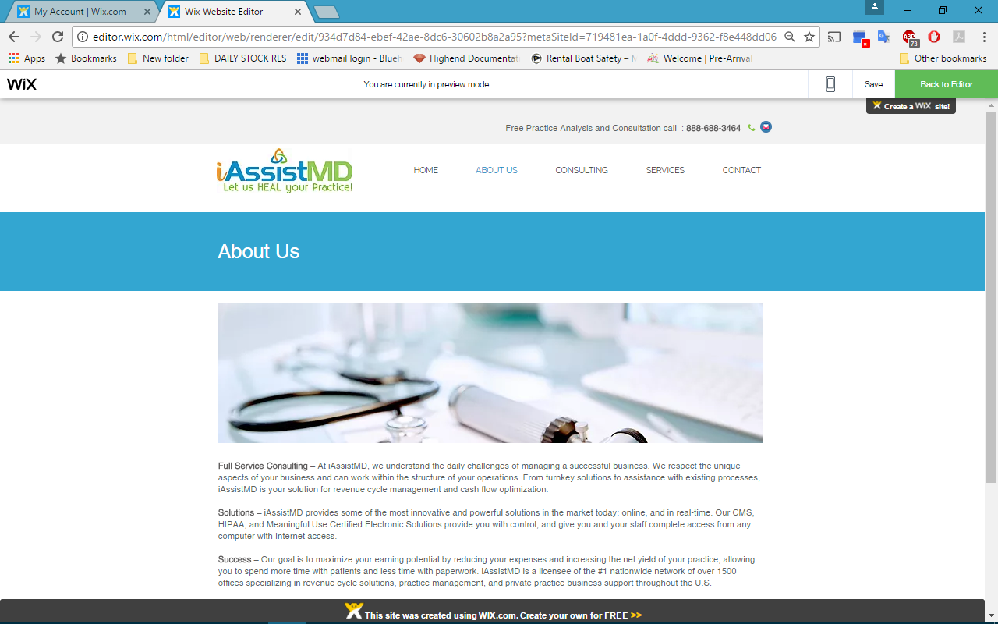

**Full Service Consulting** – At iAssistMD, we understand the daily challenges of managing a successful business. We respect the unique aspects of your business and can work within the structure of your operations. From turnkey solutions to assistance with existing processes, iAssistMD is your solution for revenue cycle management and cash flow optimization.  
  
**Solutions** – iAssistMD provides some of the most innovative and powerful solutions in the market today: online, and in real-time. Our CMS, HIPAA, and Meaningful Use Certified Electronic Solutions provide you with control, and give you and your staff complete access from any computer with Internet access.  
  
**Success** – Our goal is to maximize your earning potential by reducing your expenses and increasing the net yield of your practice, allowing you to spend more time with patients and less time with paperwork. iAssistMD is a licensee of the #1 nationwide network of over 1500 offices specializing in revenue cycle solutions, practice management, and private practice business support throughout the U.S.  
  
We understand how important it is for you to save money without investing in expensive hardware, software, networks, and other technological equipment. We will provide you with the personal attention you deserve, and partner with you to ensure your business achieves maximum profitability and efficiency.  
  
If you would like to receive a FREE Practice Analysis, contact us today.  
  
We're looking forward to working with you!



1. CONSULTATION

EHR/EMR System

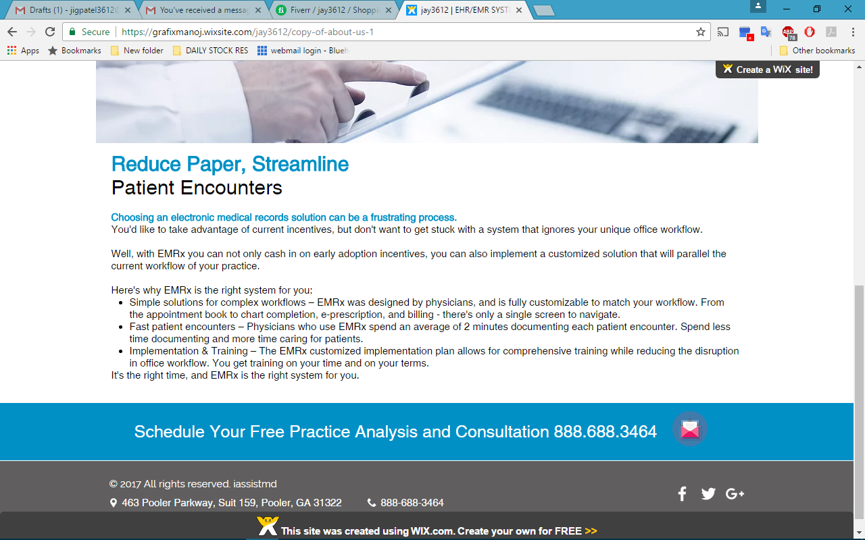

# Reduce Paper, Streamline Patient Encounters

# Choosing an electronic medical records solution can be a frustrating process.

You'd like to take advantage of current incentives, but don't want to get stuck with a system that ignores your unique office workflow.  
  
Well, with EMRx you can not only cash in on early adoption incentives, you can also implement a customized solution that will parallel the current workflow of your practice.  
  
**Here's why EMRx is the right system for you:**

* Simple solutions for complex workflows – EMRx was designed by physicians, and is fully customizable to match your workflow. From the appointment book to chart completion, e-prescription, and billing - there's only a single screen to navigate.
* Fast patient encounters – Physicians who use EMRx spend an average of 2 minutes documenting each patient encounter. Spend less time documenting and more time caring for patients.
* Implementation & Training – The EMRx customized implementation plan allows for comprehensive training while reducing the disruption in office workflow. You get training on your time and on your terms.

It's the right time, and EMRx is the right system for you.

Audit Guard

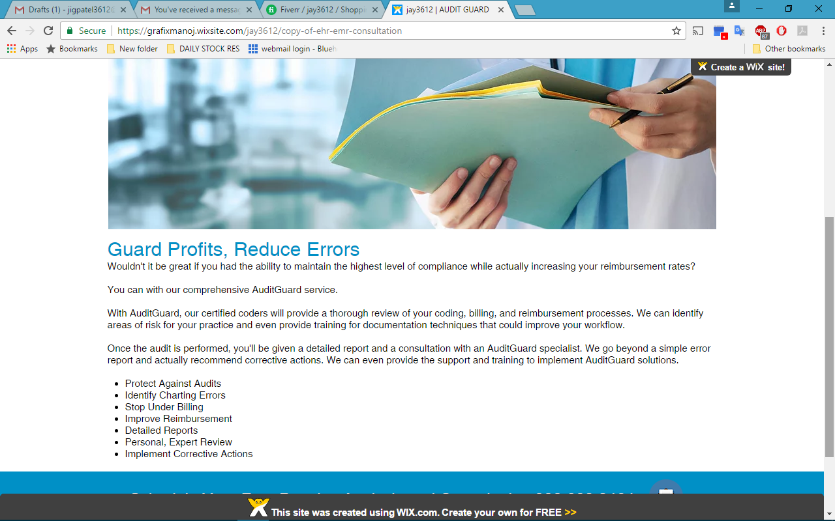

# Guard Profits, Reduce Errors

Wouldn't it be great if you had the ability to maintain the highest level of compliance while actually increasing your reimbursement rates?  
  
You can with our comprehensive AuditGuard service.  
  
With Audit Guard, our certified coders will provide a thorough review of your coding, billing, and reimbursement processes. We can identify areas of risk for your practice and even provide training for documentation techniques that could improve your workflow.  
  
Once the audit is performed, you'll be given a detailed report and a consultation with an Audit Guard specialist. We go beyond a simple error report and actually recommend corrective actions. We can even provide the support and training to implement Audit Guard solutions.​

* Protect Against Audits
* Identify Charting Errors
* Stop Under Billing
* Improve Reimbursement
* Detailed Reports
* Personal, Expert Review
* Implement Corrective Actions

Credentialing

1. SERVICES

Billing

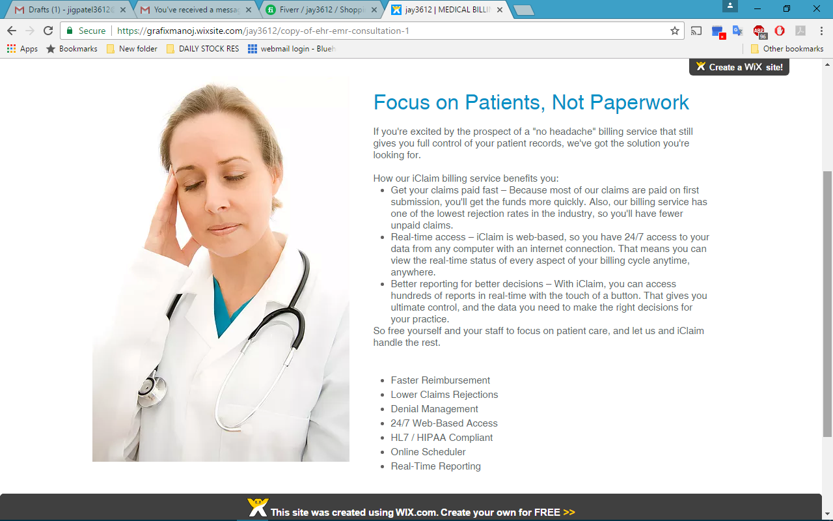

# Focus on Patients, Not Paperwork

If you're excited by the prospect of a "no headache" billing service that still gives you full control of your patient records, we've got the solution you're looking for.  
**How our "no headache" billing service benefits you:**

* Get your claims paid fast – Because most of our claims are paid on first submission, you'll get the funds more quickly. Also, our billing service has one of the lowest rejection rates in the industry, so you'll have fewer unpaid claims.​
* Real-time access – iClaim is web-based, so you have 24/7 access to your data from any computer with an internet connection. That means you can view the real-time status of every aspect of your billing cycle anytime, anywhere.​
* Better reporting for better decisions – With iClaim, you can access hundreds of reports in real-time with the touch of a button. That gives you ultimate control, and the data you need to make the right decisions for your practice.​

So free yourself and your staff to focus on patient care, and let us and iClaim handle the rest.

* Faster Reimbursement
* Lower Claims Rejections
* Denial Management
* 24/7 Web-Based Access
* HL7 / HIPAA Compliant
* Online Scheduler
* Real-Time Reporting

iDocsNOW

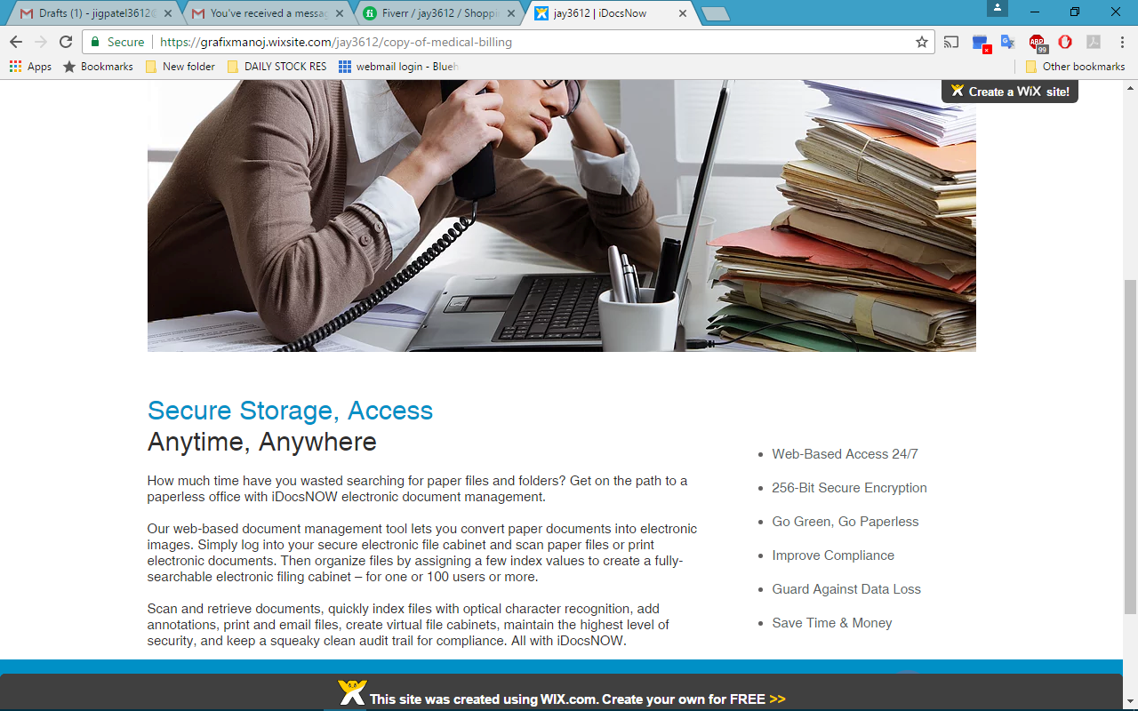

# Secure Storage, Access Anytime, Anywhere​

How much time have you wasted searching for paper files and folders? Get on the path to a paperless office with iDocsNOW electronic document management.  
  
Our web-based document management tool lets you convert paper documents into electronic images. Simply log into your secure electronic file cabinet and scan paper files or print electronic documents. Then organize files by assigning a few index values to create a fully-searchable electronic filing cabinet – for one or 100 users or more.  
  
Scan and retrieve documents, quickly index files with optical character recognition, add annotations, print and email files, create virtual file cabinets, maintain the highest level of security, and keep a squeaky clean audit trail for compliance. All with iDocsNOW.

* Web-Based Access 24/7
* 256-Bit Secure Encryption
* Go Green, Go Paperless
* Improve Compliance
* Guard Against Data Loss
* Save Time & Money

Auto Card

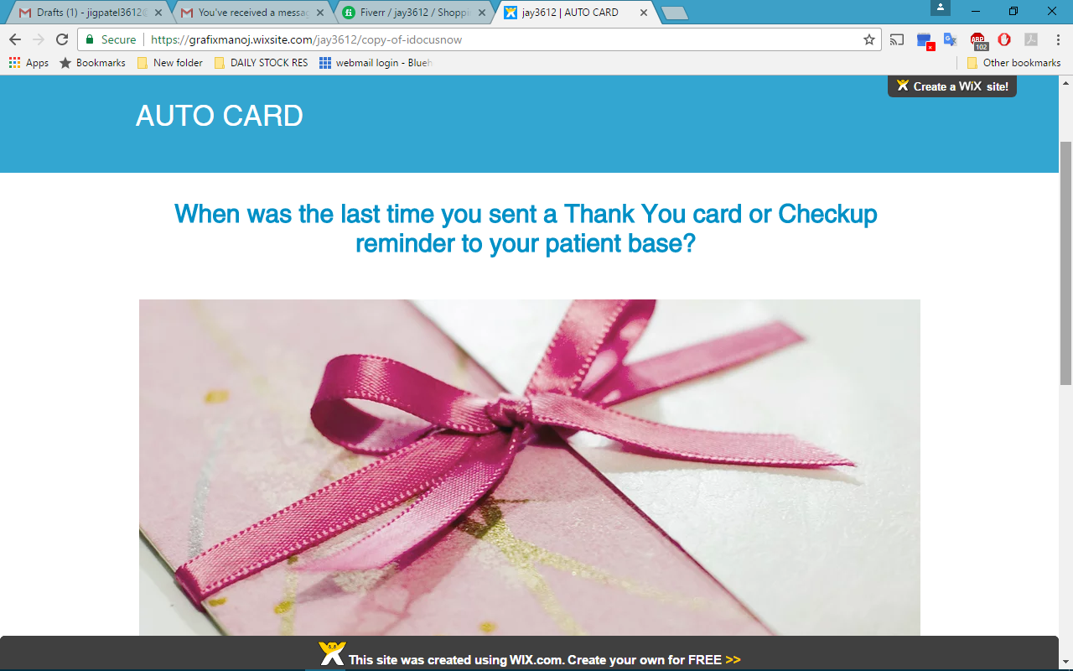

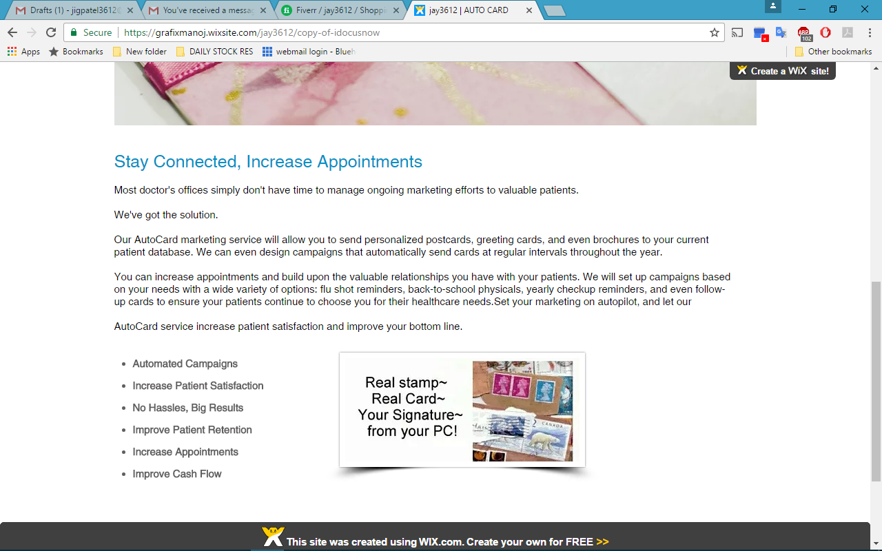

**Stay Connected, Increase Appointments**

Most doctor's offices simply don't have time to manage ongoing marketing efforts to valuable patients.

We've got the solution.

Our AutoCard marketing service will allow you to send personalized postcards, greeting cards, and even brochures to your current patient database. We can even design campaigns that automatically send cards at regular intervals throughout the year.

You can increase appointments and build upon the valuable relationships you have with your patients. We will set up campaigns based on your needs with a wide variety of options: flu shot reminders, back-to-school physicals, yearly checkup reminders, and even follow-up cards to ensure your patients continue to choose you for their healthcare needs.Set your marketing on autopilot, and let our

AutoCard service increase patient satisfaction and improve your bottom line.

* Automated Campaigns
* Increase Patient Satisfaction
* No Hassles, Big Results
* Improve Patient Retention
* Increase Appointments
* Improve Cash Flow

Quick Collect

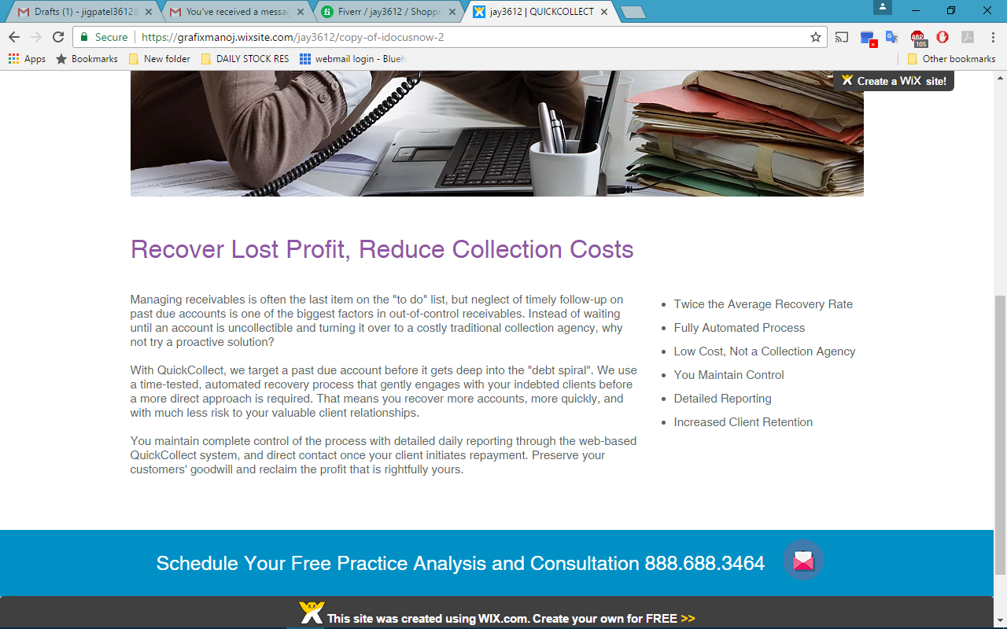

# Recover Lost Profit, Reduce Collection Costs

Managing receivables is often the last item on the "to do" list, but neglect of timely follow-up on past due accounts is one of the biggest factors in out-of-control receivables. Instead of waiting until an account is uncollectible and turning it over to a costly traditional collection agency, why not try a proactive solution?  
  
With QuickCollect, we target a past due account before it gets deep into the "debt spiral". We use a time-tested, automated recovery process that gently engages with your indebted clients before a more direct approach is required. That means you recover more accounts, more quickly, and with much less risk to your valuable client relationships.  
  
You maintain complete control of the process with detailed daily reporting through the web-based QuickCollect system, and direct contact once your client initiates repayment. Preserve your customers' goodwill and reclaim the profit that is rightfully yours.

* Twice the Average Recovery Rate
* Fully Automated Process
* Low Cost, Not a Collection Agency
* You Maintain Control
* Detailed Reporting
* Increased Client Retention

1. Contact Us

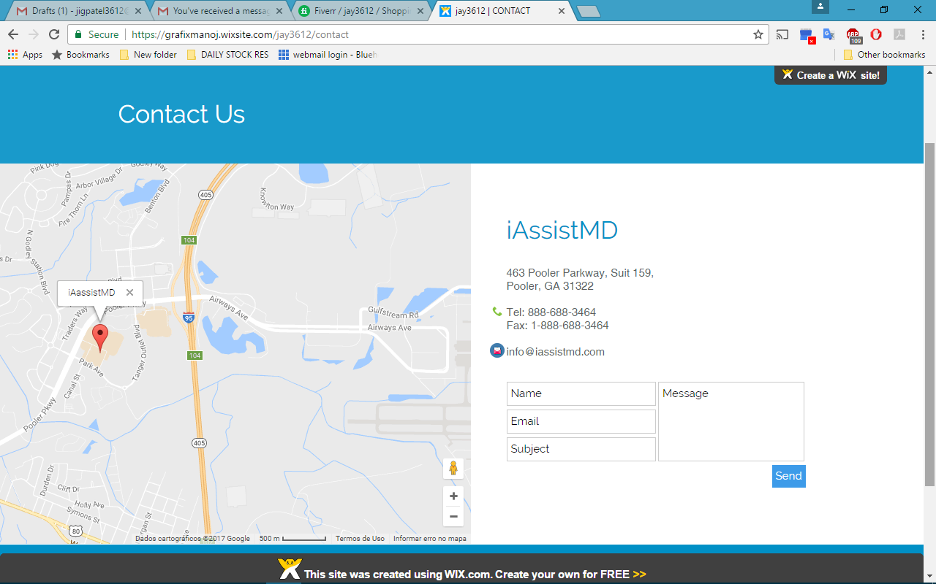

I need a link for below table and form into footer section please.

"Click here for our **Referral Program”**

|  |  |  |
| --- | --- | --- |
| **Referral Program**  iAssistMD – The “NO HEADACHE” billing service | | |
| Bronze | Silver | Gold |
| * Refer a practice billing minimum of **$50k - $99k** per month * Referral Bonus **$500.00** | * Refer a practice billing minimum of **$100k - $199k** per month * Referral Bonus **$1000.00** | * Refer a practice billing minimum of **$200k** or more per month * Referral Bonus **$1500.00** |
| **Let us HEAL your Practice So you can FOCUS on Patients (please highlight this line with color theme)** | | |

I need a form to fill out for above referral program.

**Your information**

-First & Last name, Phone number, email & address.

**Practice information**

-Practice Name*

-office manager name*

-number of provider*

-practice specialty *

-Best contact info*

-Gross monthly Rev.*

(Please select one option)*

50k-99k

100k-199k

200k or more

-Anything we should know about your referral (optional)

This form summit to [info@iassistmd.com](mailto:info@iassistmd.com)